**Practical No. 3**

1. **Working with Node.JS :- Installation, Setting Environment variable, Creating Server, Working with user defined and built-in modules.**
2. **Installation**

**Step 1: Go to www.nodejs.org and download Setup**

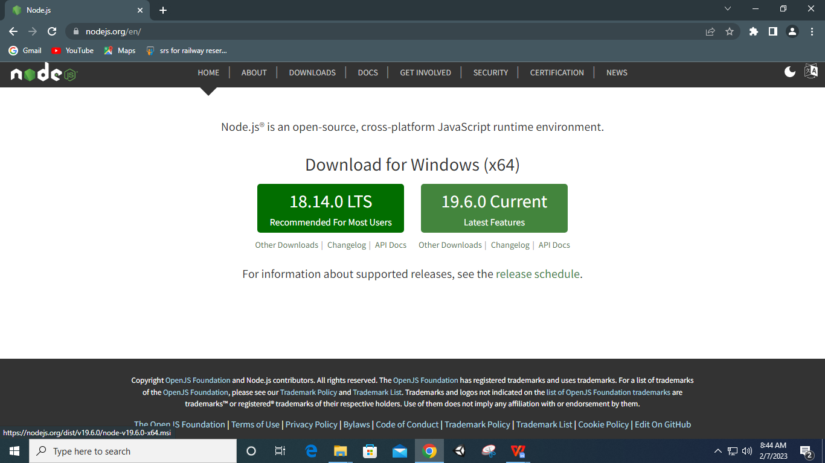

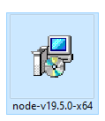

**Step 2: Install Setup**

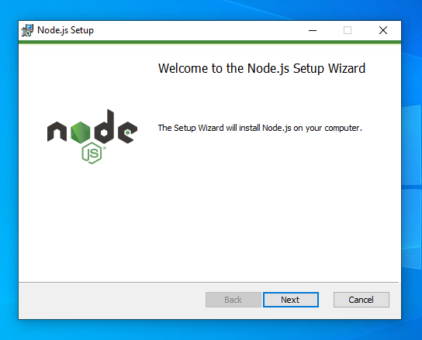

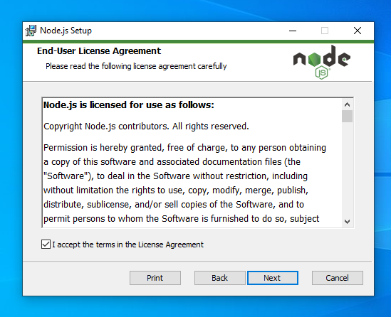

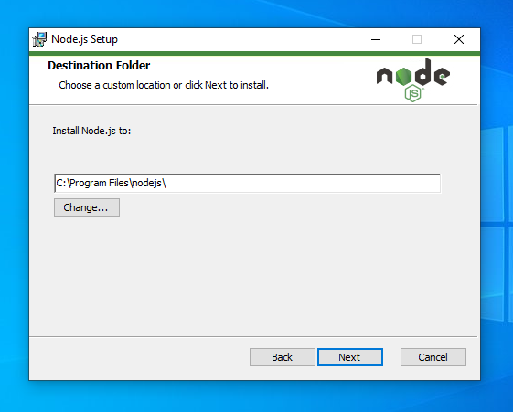

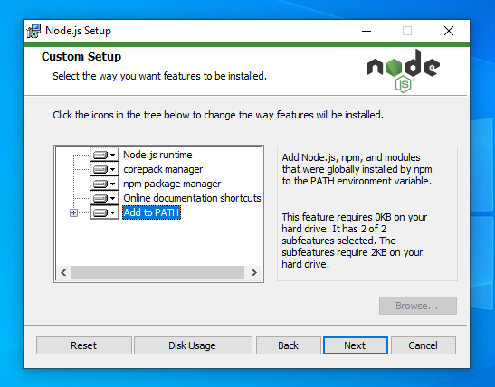

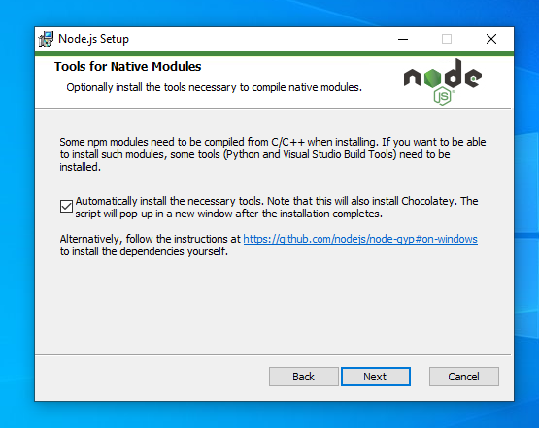

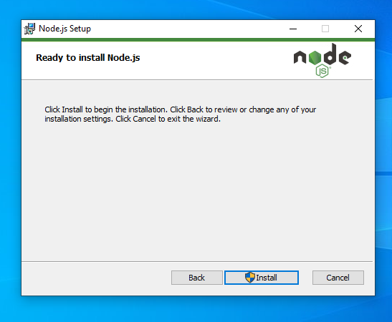

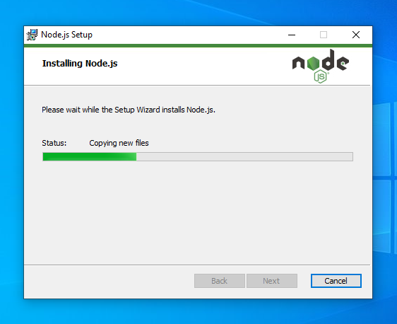

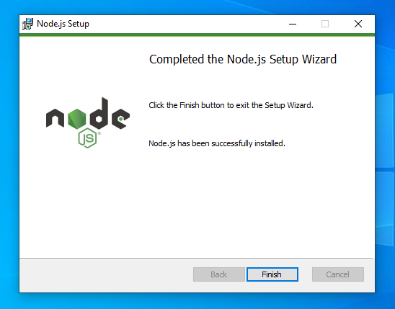

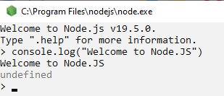

1. **Setting Environment Variable**

**Step 1: Copy the path to nodejs folder files.**

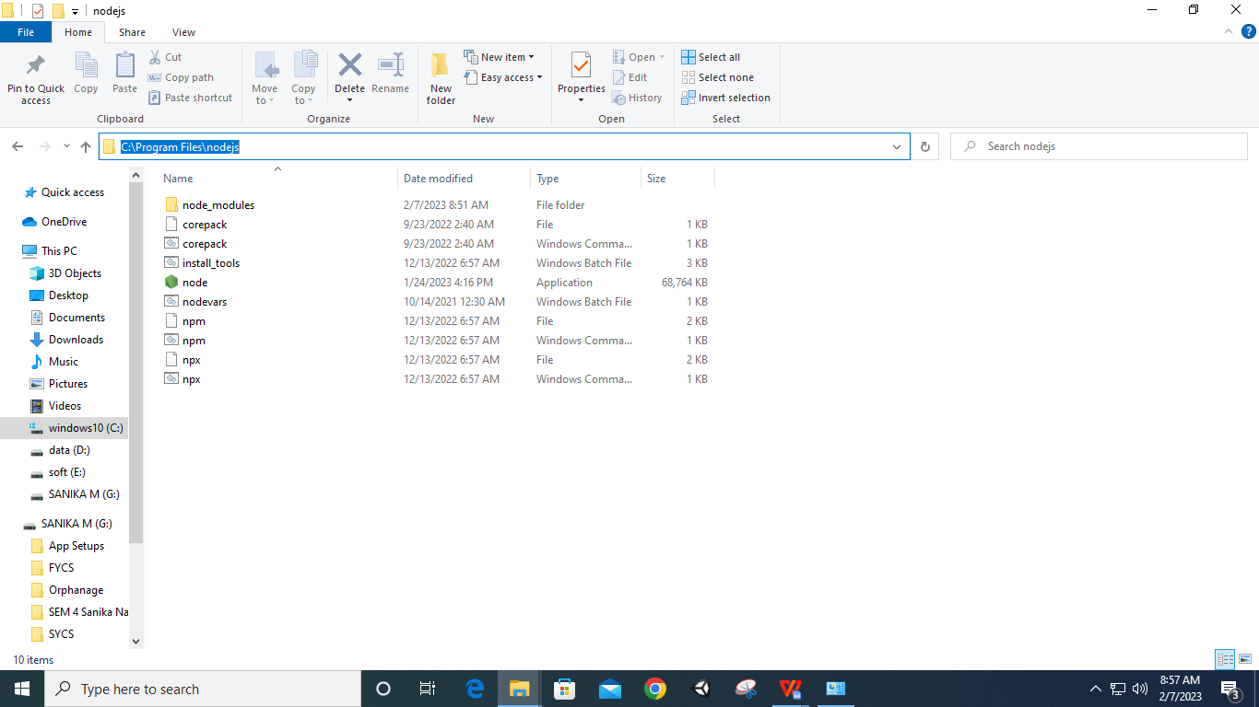

**Step 2: Go to control panel - system and select ‘advanced system setup’**

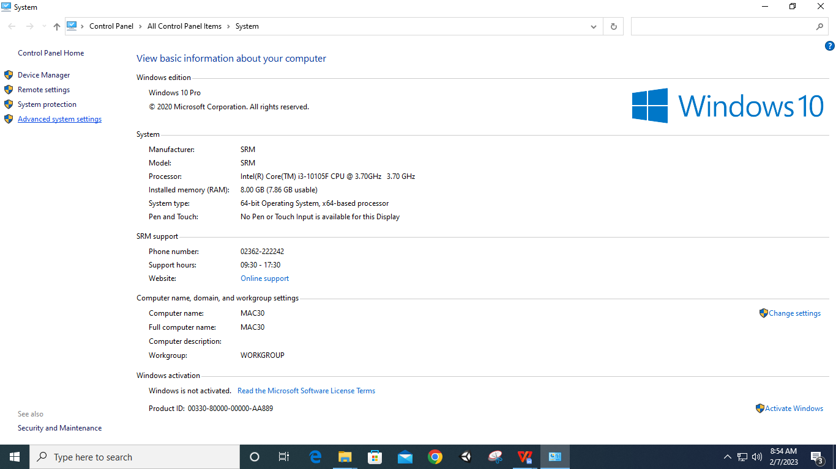

**Step 3: Select ‘Environment Variables…’**

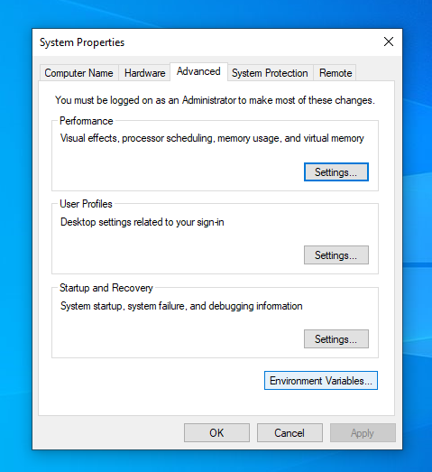

**Step 4: In User-variables select ‘path’ and create new path by using copied nodejs path**

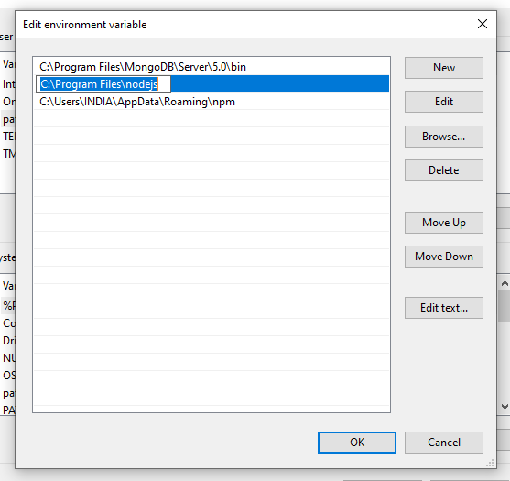

**Step 5: In System-variables select ‘path’ and create new path by using copied nodejs path**

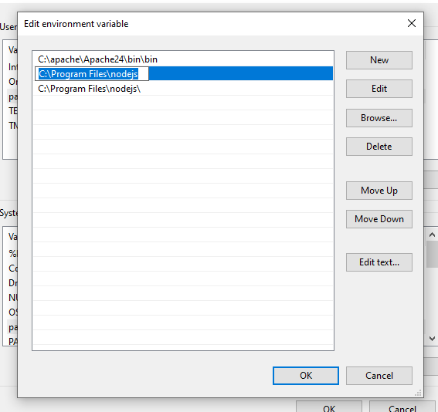

**Step 6: Click ‘OK’**

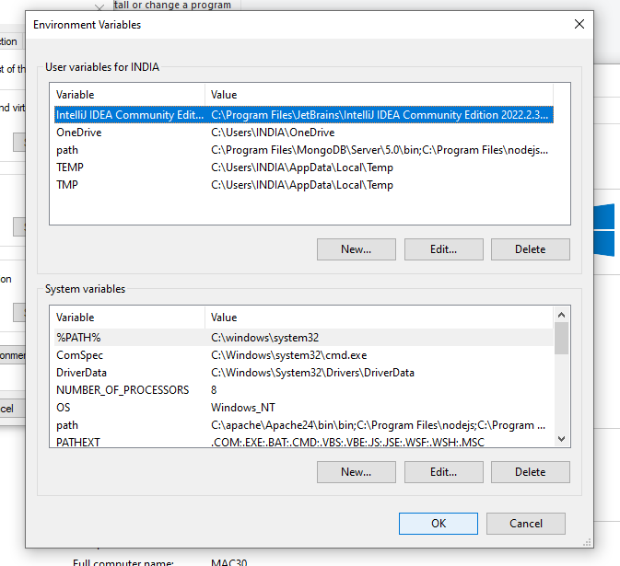

1. **Creating Server**

**Code:**

var http=require('http');

http.createServer(function(req,res){

res.writeHead(200,{'Content-Type':'text/html'});

res.end("Welcome to Node.JS Server");

}).listen(8080);

**Output:**

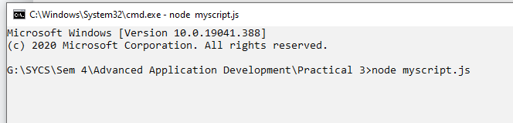

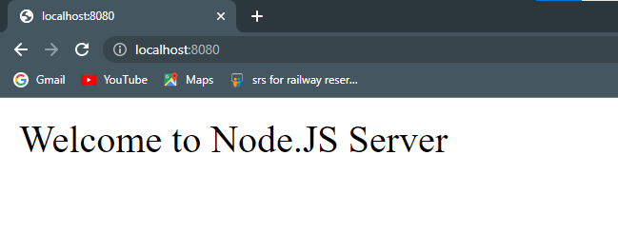

1. **Working with User-defined and Built-in Modules**

**Code:**

**mymodule.js**

exports.mydate=function(){

return Date();

}

exports.message=function(){

return "Welcome message from mymodule"

}

**mymoduleimpl.js**

var http=require('http')

var md=require('./mymodule');

http.createServer(function(req,res){

res.writeHead(200,{'Content-Type':'text/html'});

res.write("Current Date and Time is "+md.mydate());

res.write(" Message returned is "+md.message());

}).listen(8040);

**Output:**

